Opiniano, Ezkylle 01/20/2026
NW – 301 6BLOCKTECH
Midterm Lab Activity 2: Display the Metamask Account Balance using Web3.js
Index.html
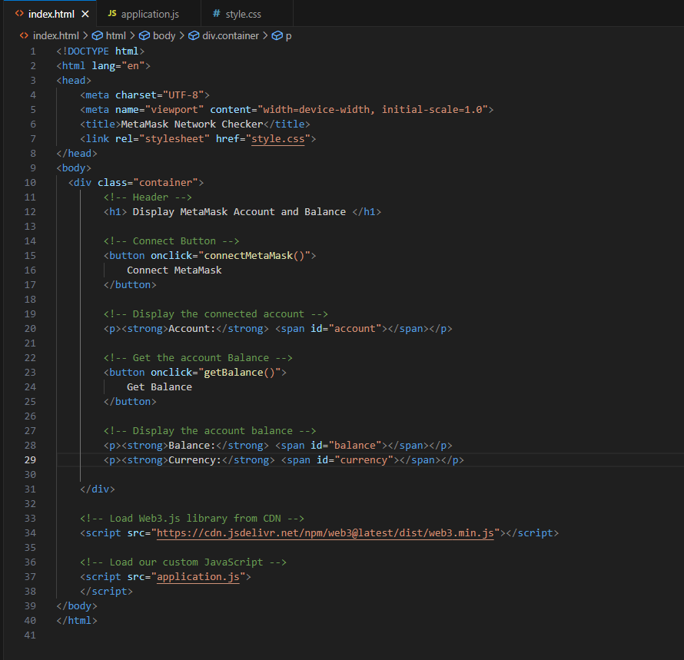

Application.js
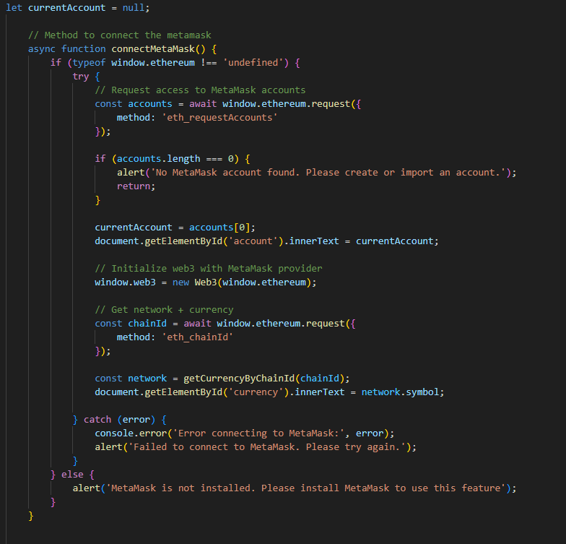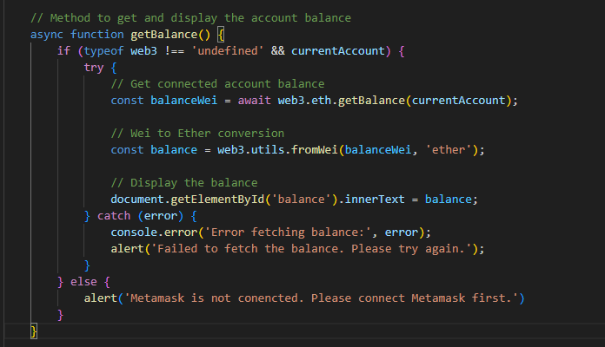


Style.css
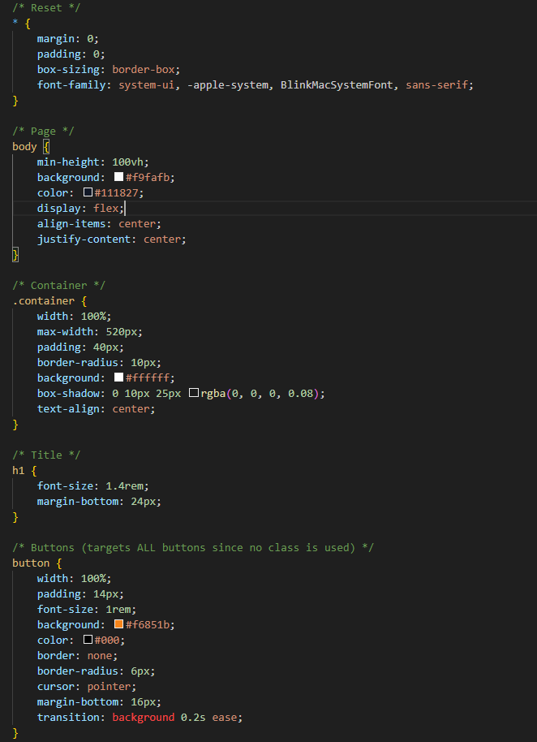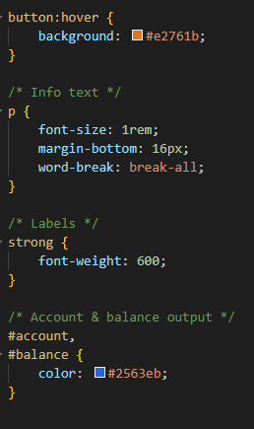

Reflection:
This project exhibits a very clear and practical integration of a web interface with MetaMask through the use of Web3.js. Its architecture is very well-structured and well-organized, as it clearly separates different parts of the application which are HTML for layout, CSS for styling, and JavaScript for blockchain logic. The UI has a very clean and user-friendly design which also helps in making it very easy for users to connect their MetaMask wallet, display their account address, view their balance, and recognize the current network currency.

The application from the perspective of functionality does support all the actions of MetaMask connection correctly, gets the active account, finds out the current blockchain network through chainId, and even changes the currency when a user switches networks. The chainChanged event is being listened to which guarantees that the information displayed is always accurate and that is a very important point in blockchain applications with respect to usability and correctness.

In conclusion, this implementation is a reflection of a strong grasp of basic decentralized application (dApp) concepts, good UI/UX practices, and responsible handling of wallet state changes.

